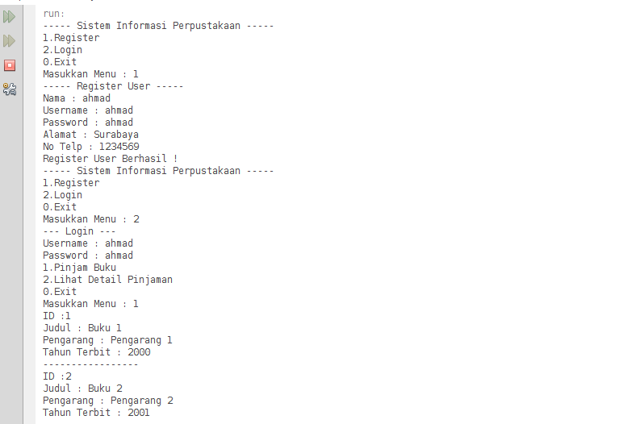

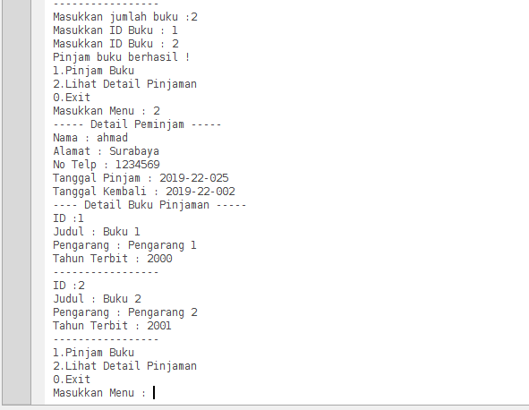

Keterangan Source Code :

-------------------------------------------------------------------------------------------

-----------------------------------------------------------------------------------------------------------------------------------------------------------------------------------------------------------------------------------------------------------------------------------------------------------------------------------------------------------------------------------------------------------------------------------------------------------------------------------------------------------------------------------------------------------------------------------------------------------------------------------------------------------------------------------------------------------------------------------------------------------------------------------------------------------------------------------------------------------------------------------------------------------------------------------------------------------------------------------------------------------------------------------------

-------------------------------------------------------------------------------------------

-----------------------------------------------------------------------------------------------------------------------------------------------------------------------------------------------------------------------------------------------------------------------------------------------------------------------------------------------------------------------------------------------------------------------------------------------------------------------------------------------------------------------------------------------------------------------------------------------------------------------------------------------------------------------------------------------------------------------------------------------------------------------------------------------------------------------------------------------------------------------------------------------------------------------------------------------------------------------------------------------------------------------------------------

-------------------------------------------------------------------------------------------

-----------------------------------------------------------------------------------------------------------------------------------------------------------------------------------------------------------------------------------------------------------------------------------------------------------------------------------------------------------------------------------------------------------------------------------------------------------------------